Working with Merge Conflicts

1. Download Kdiff3 and update git Global configurations on your laptop

Homepage: http://kdiff3.sourceforge.net
Download Kdiff3 from https://sourceforge.net/projects/kdiff3/files/

KDiff3 is a program that
- compares and merges two or three input files or directories,
- shows the differences line by line and character by character (!),
- provides an automatic merge-facility and
- an integrated editor for comfortable solving of merge-conflicts
- and has an intuitive graphical user interface.

Run the below command in Git Bash to configure kdiff3
git config --global merge.tool kdiff3
git config --global mergetool.kdiff3.cmd '"C:\Program Files\KDiff3\kdiff3" $BASE $LOCAL $REMOTE -o $MERGED '

chait@LAPTOP-QHKO7HQH MINGW64 ~
$ mkdir merge

chait@LAPTOP-QHKO7HQH MINGW64 ~
$ cd merge

chait@LAPTOP-QHKO7HQH MINGW64 ~/merge
$ git init
Initialized empty Git repository in C:/Users/chait/merge/.git/

chait@LAPTOP-QHKO7HQH MINGW64 ~/merge
$ vi index.html
<html>
<head>
This is a merge conflict example
<body>
master changes
</html>

:wq

chait@LAPTOP-QHKO7HQH MINGW64 ~/merge (master)
$ git add index.html
warning: in the working copy of 'index.html', LF will be replaced by CRLF the next time Git touches it

chait@LAPTOP-QHKO7HQH MINGW64 ~/merge (master)
$ git commit -m "masterchanges"
[master (root-commit) b239643] maste changes
1 file changed, 6 insertions(+)
create mode 100644 index.html

chait@LAPTOP-QHKO7HQH MINGW64 ~/merge (master)
$ git branch b1

chait@LAPTOP-QHKO7HQH MINGW64 ~/merge (master)
$ git checkout b1
Switched to branch 'b1'

chait@LAPTOP-QHKO7HQH MINGW64 ~/merge (b1)
$ vi index.html

<html>
<head>
This is a merge conflict example
<body>
b1 changes
</html>

:wq

chait@LAPTOP-QHKO7HQH MINGW64 ~/merge(b1)
$ git add index.html
warning: in the working copy of 'index.html', LF will be replaced by CRLF the next time Git touches it

chait@LAPTOP-QHKO7HQH MINGW64 ~/merge (b1)
$ git commit -m "b1 changes"
[b1 71eb126] b1 changes
1 file changed, 1 insertion(+), 1 deletion(-)

chait@LAPTOP-QHKO7HQH MINGW64 ~/merge (b1)
$ git checkout master
Switched to branch 'master'

chait@LAPTOP-QHKO7HQH MINGW64 ~/merge (master)
$ git branch b2

chait@LAPTOP-QHKO7HQH MINGW64 ~/merge (master)
$ git checkout b2
Switched to branch 'b2

chait@LAPTOP-QHKO7HQH MINGW64 ~/merge (b2)
$ vi index.html

<html>
<head>
This is a merge conflict example
<body>
b2 changes
</html>

:wq

chait@LAPTOP-QHKO7HQH MINGW64 ~/merge(b2)
$ git add index.html
warning: in the working copy of 'index.html', LF will be replaced by CRLF the next time Git touches it

chait@LAPTOP-QHKO7HQH MINGW64 ~/merge (b2)
$ git commit -m "b2 changes"
[b1 71eb126] b2 changes
1 file changed, 1 insertion(+), 1 deletion(-)

chait@LAPTOP-QHKO7HQH MINGW64 ~/merge (b2)
$ git checkout master
Switched to branch 'master'
M index.html

chait@LAPTOP-QHKO7HQH MINGW64 ~/merge (master)
$ git merge b1
Updating 23afb7d..51e2283
Fast-forward
index.html | 2 +-
1 file changed, 1 insertion(+), 1 deletion(-)

chait@LAPTOP-QHKO7HQH MINGW64 ~/merge (master)
$ git merge b2
Auto-merging index.html
CONFLICT (content): Merge conflict in index.html
Automatic merge failed; fix conflicts and then commit the result.

$ git mergetool
Merging:
index.html

Normal merge conflict for 'index.html':
{local}: modified file
{remote}: modified file

It would open kdiff merge tool, decide which one you want to merge , Right Click on Merge Conflict line and choose the options. For this lab we are choosing “Select Line(s) from C”.Save it and close the window
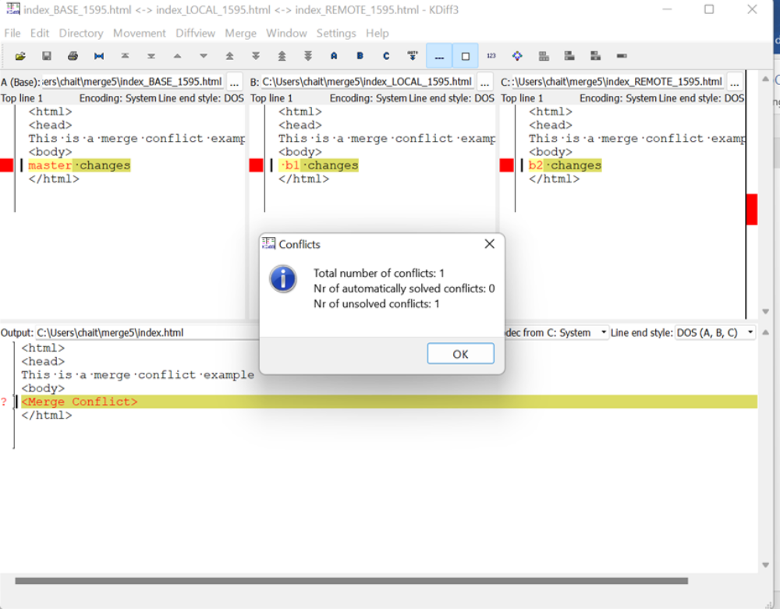

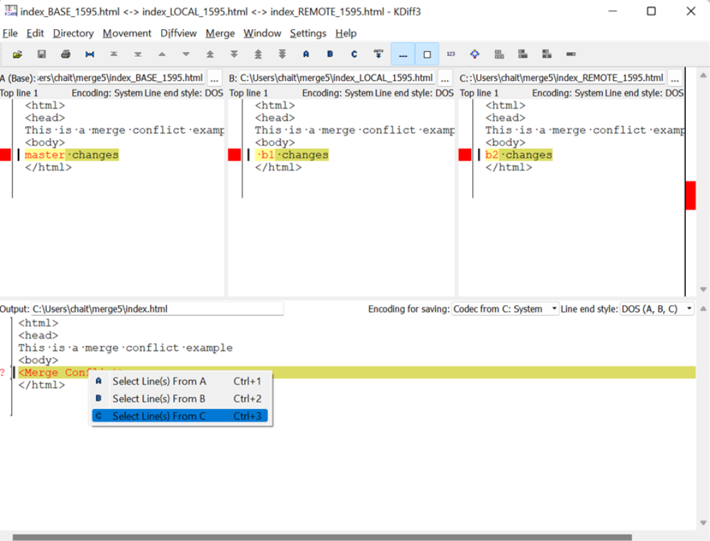

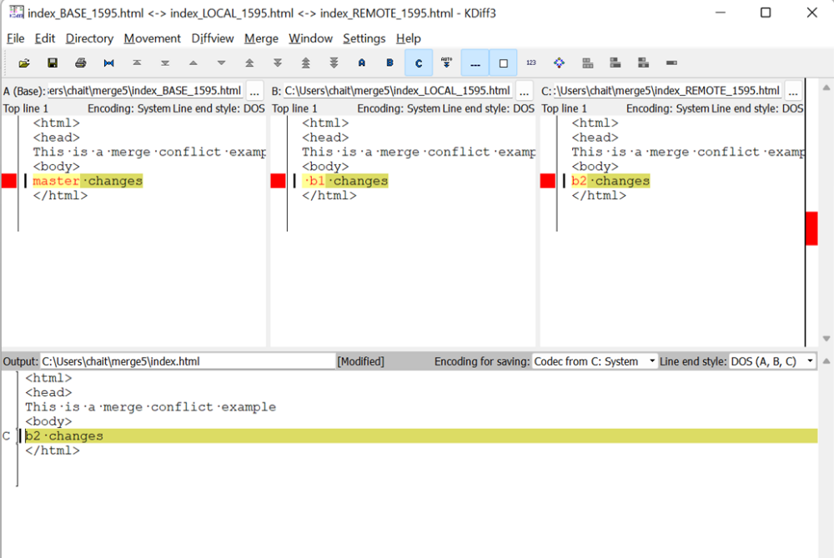

chait@LAPTOP-QHKO7HQH MINGW64 ~/merge (master|MERGING)
$ git commit
[master b1820af] Merge branch 'b2'

Observe it has taken b2 changes
chait@LAPTOP-QHKO7HQH MINGW64 ~/merge (master)
$ cat index.html
<html>
<head>
This is a merge conflict example
<body>
b2 changes
</html>

